EX NO 8: Line Numbering of a File Using LEX

Aim:
To write a LEX program to read an input file and display its contents with line numbers on standard output.
Algorithm:
- Start the program.
- Initialize the line number to 1.
- Read the input file line by line.
- Print each line with its corresponding line number.
- Increment the line number for each new line.
- Stop the program.
Program:

%{
#include <stdio.h>
int line = 1;
%}

%%
\n { printf("\n"); line++; printf("%d: ", line); }
. { ECHO; }
%%

int main()
{
printf("1: ");
yylex();
return 0;
}

int yywrap()
{
return 1;
}Sample input:
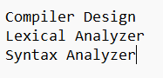

Sample output:
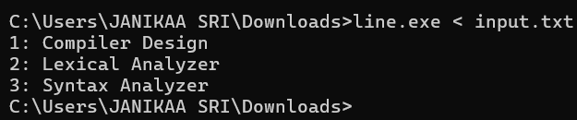

Result:
The LEX program was executed successfully and identified and printed all five assignment operators: =, +=, -=, *=, and /=.

